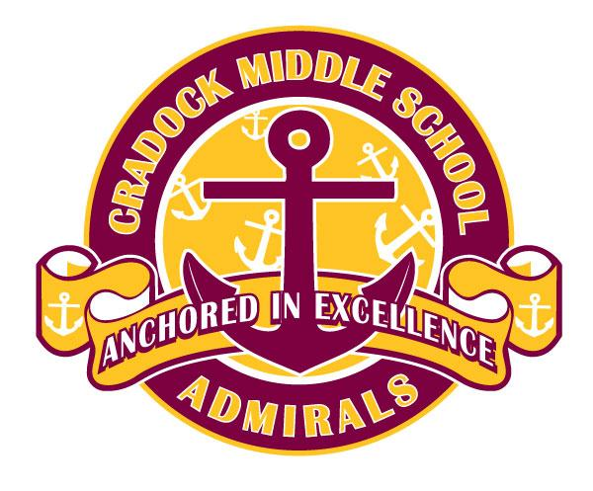
CRADOCK MIDDLE SCHOOL
School Supply List

Grade 7  1 pack of 10 ink pens  1 pack of 24 ct. pencils  3 packs of loose leaf paper  4 glue sticks  2 flash drives  2 binders (2”)  2 binders (1”)  3 composition notebooks  4 spiral notebooks  2 combination locks | Grade 8  2 report covers  2 project boards (tri-fold)  1 pack of 10 ink pens  1 pack of 24 ct. pencils  3 packs of loose leaf paper  1 glue stick  2 flash drives  2 binders (2”)  2 binders (1”)  3 composition notebooks  4 spiral notebooks  2 combination locks

**Additional items may be requested by teachers.**

